**Git Bash Snippet**

1. Initializing the git bash to git hub to clone the repository

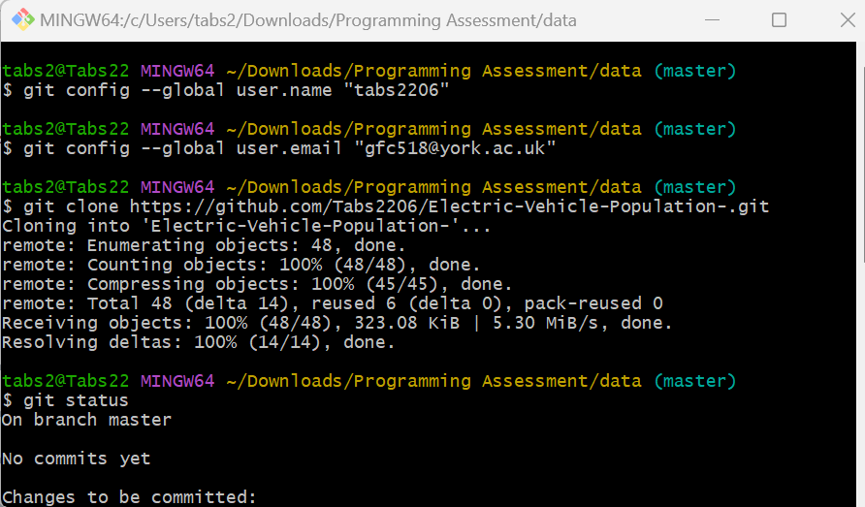

1. Create an EV each county folder and copy the file Electric_Vehicle_in_each_county_

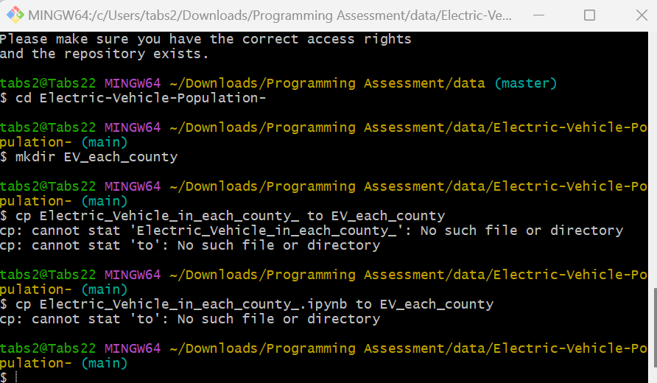

1. Create a folder Dowload_Python_code to store all the .py file

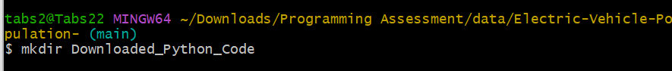

1. Copy the .py file into the EV each county folder

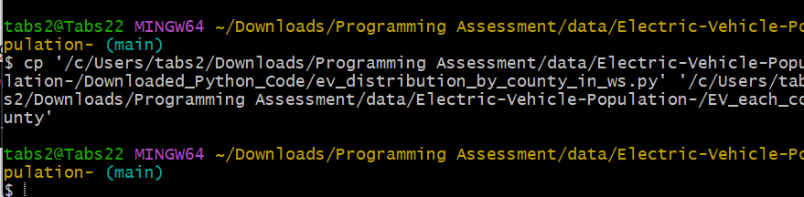

1. Change the path in the .py file added r in front of the URL so it can be read

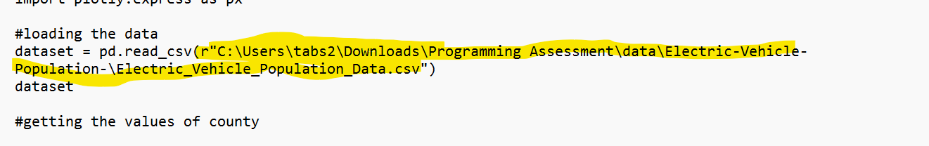

1. Running the .py file from git bash

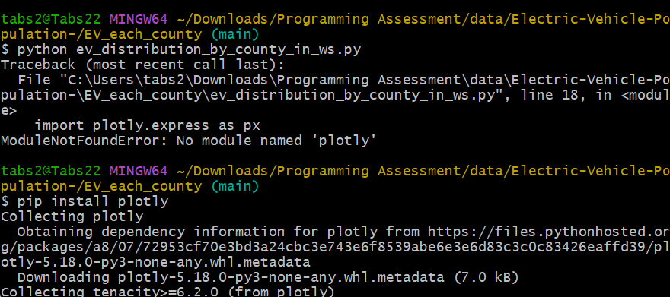

1. Got error for plotly so installing plotly

The code run successfully by .py file

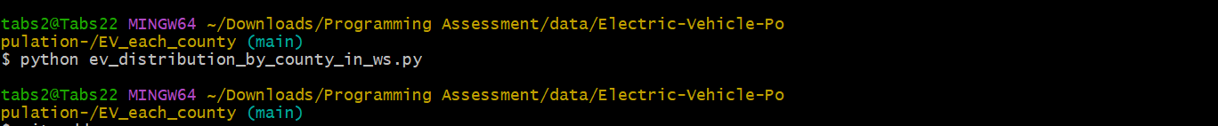

1. Added all the files generated to git using command **git add .**

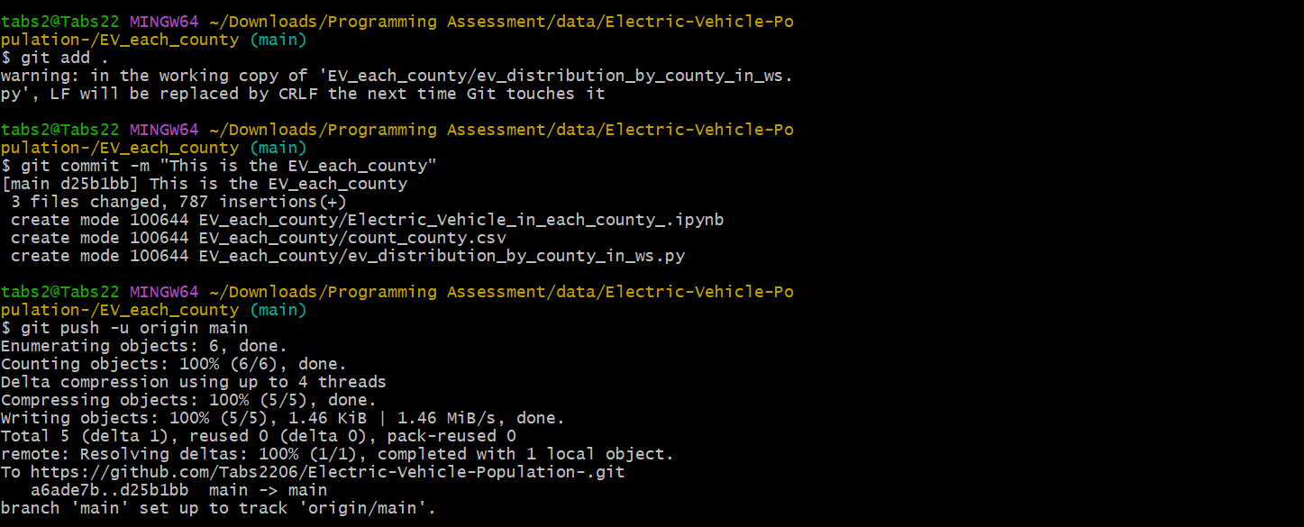

1. Added the plot image to the folder and tried to repush it but got some error

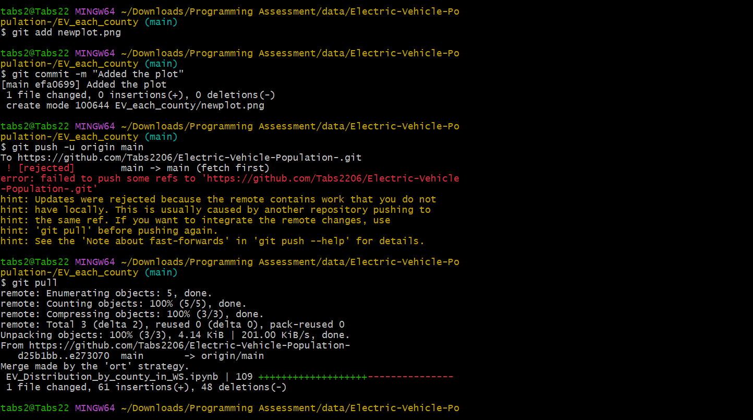

1. Added the plot image using the git hub commit

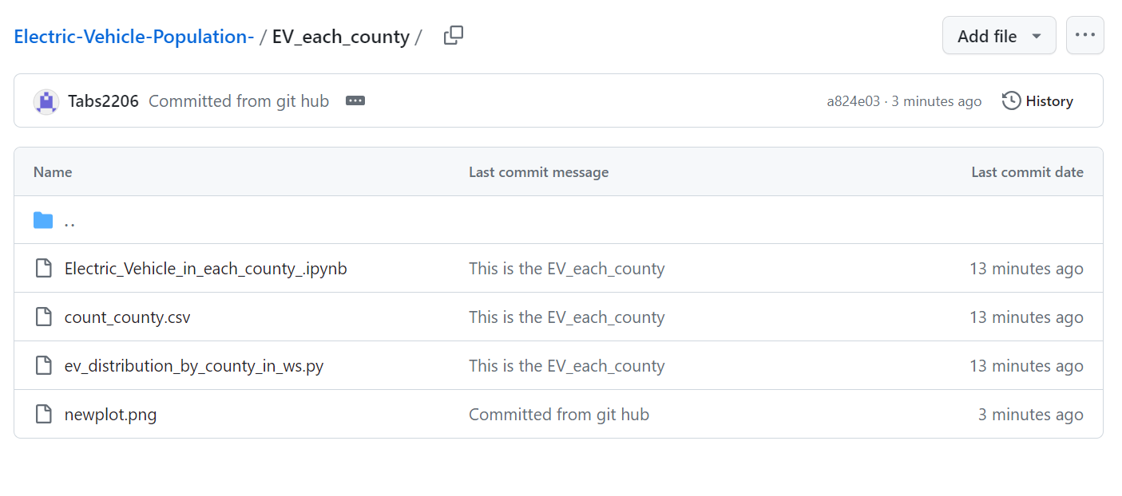

1. The directory EV_each_county as been push now creating a README.md using the nano folder for the directory.

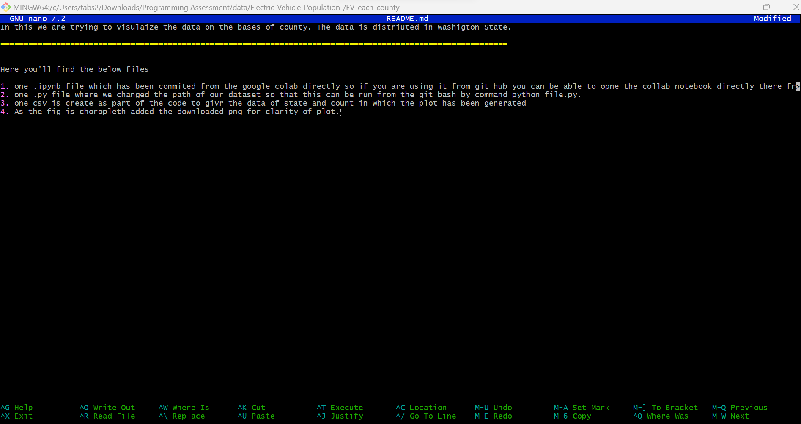

1. Pushing the file again using git add

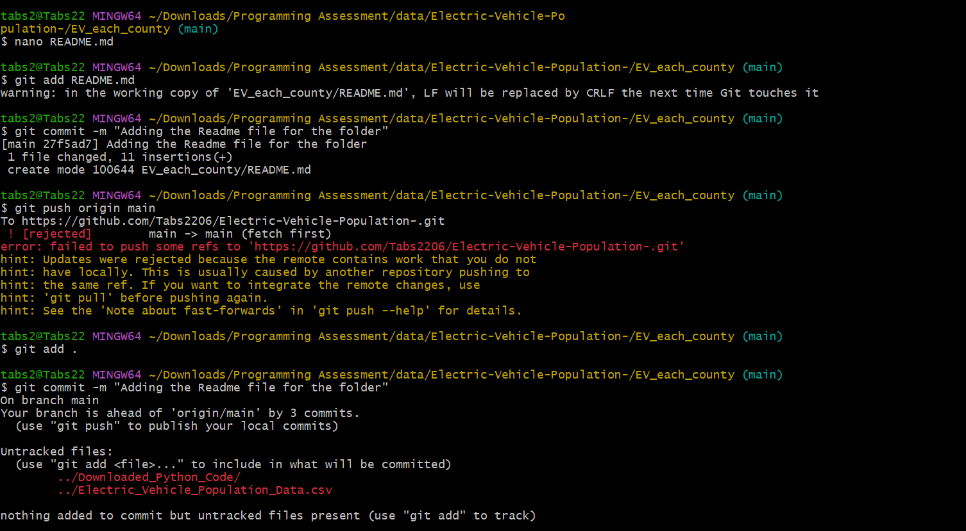

1. Running into few errors but able to resolve and commit the folder again

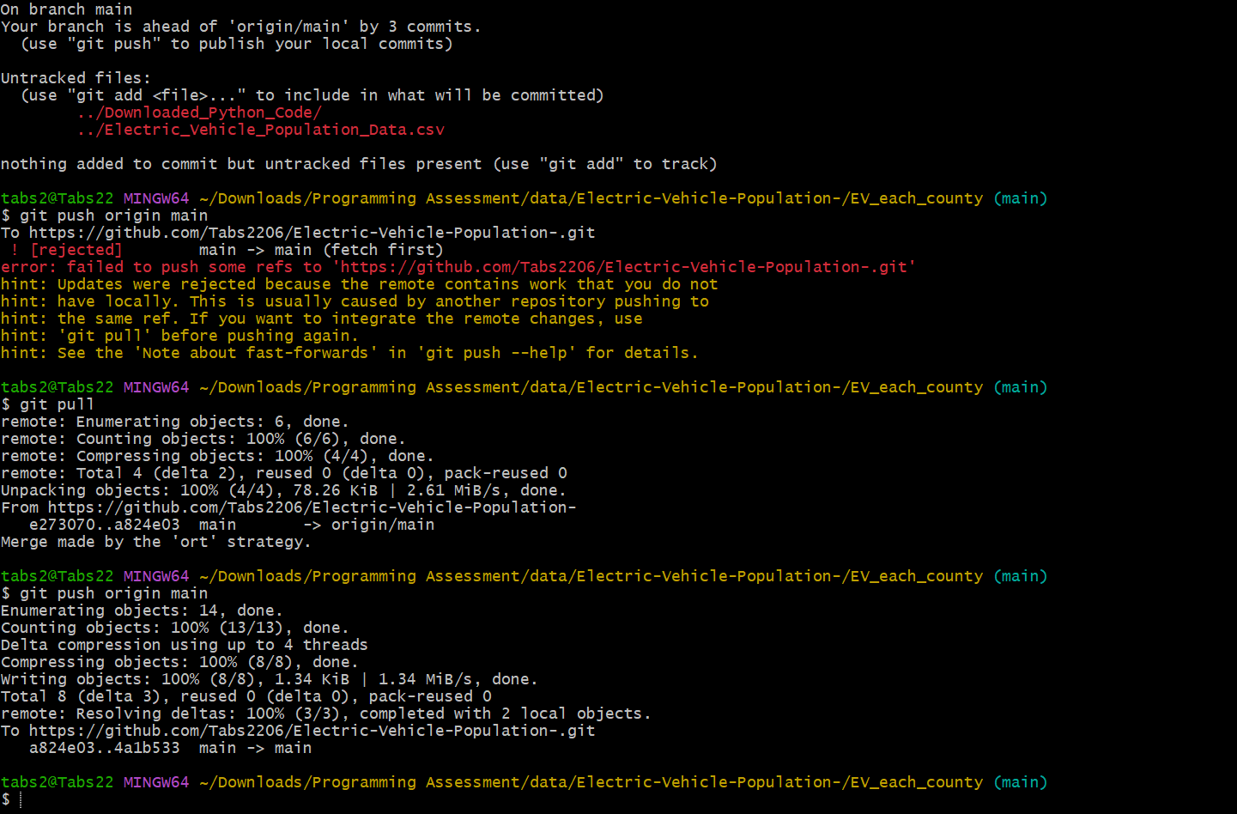

1. Created a new folder for county as the .py file is for distribution by county moved all the files from previous folder to the new folder and re-run python code and committed the code and pushed to the git hub.

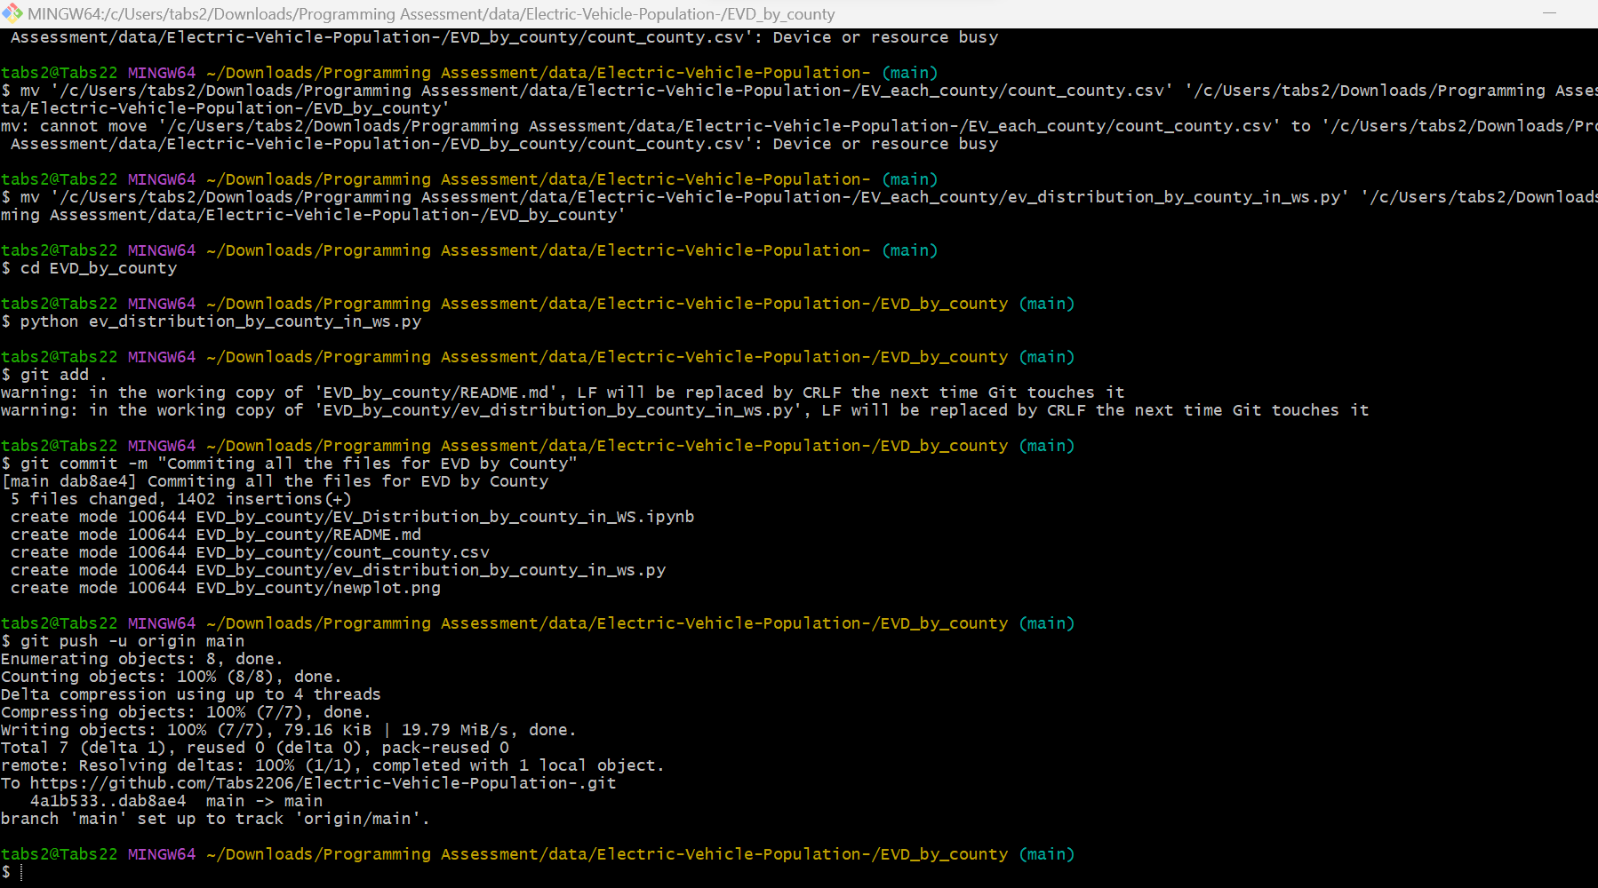

1. Added the .py code for EVP_each_county and running it in git bash by changing the path

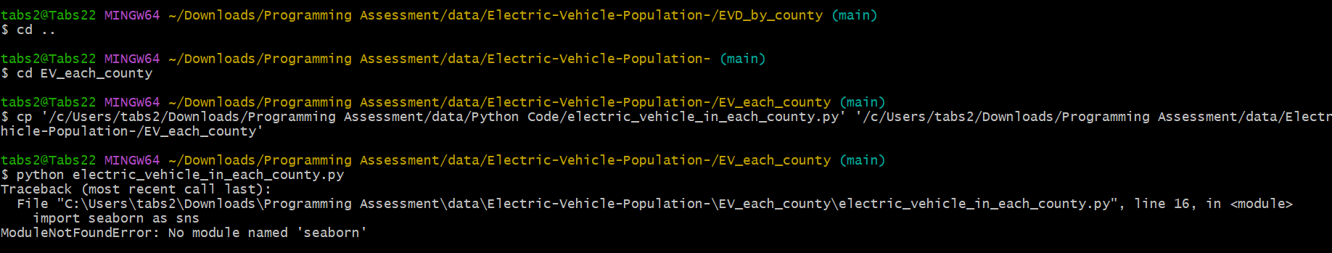

1. Got error as seaborn is not installed in the system. Run the pip install seaborn command

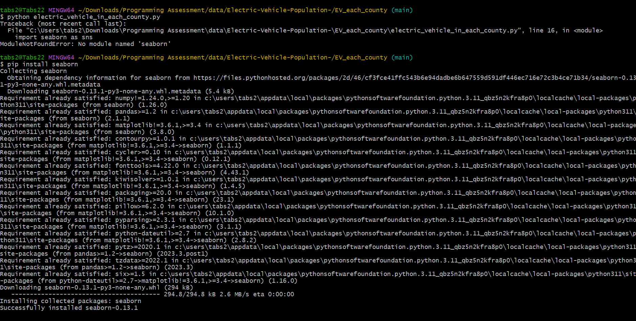

1. After running the python file.py we can see the plot it created a png and csv file on the folder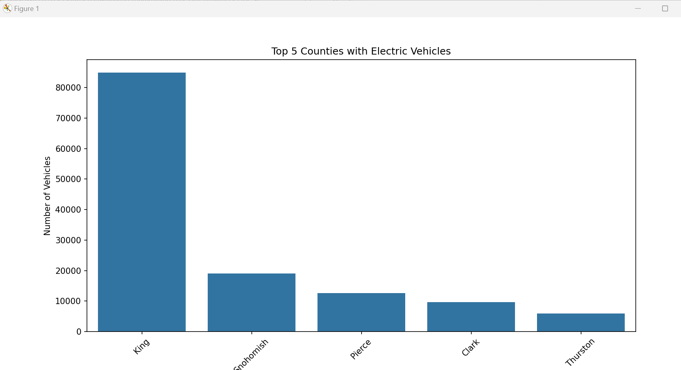
2. Add a README.md file in it explaining the files and use
3. Successfully Committed the other repository with error as below.

